Attachment：
The sheet of Guangken Rubber (Thai Southern) Co., Ltd. TSR 20 futures product logo
Registered Enterprise | Factory Code/Manufacturer (Factory) | Old Version of Product Logo | New Version of Product Logo
Guangken Rubber (Thai Southern) Co., Ltd. | DB | 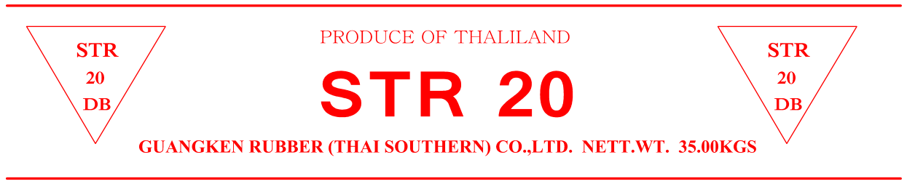 | 